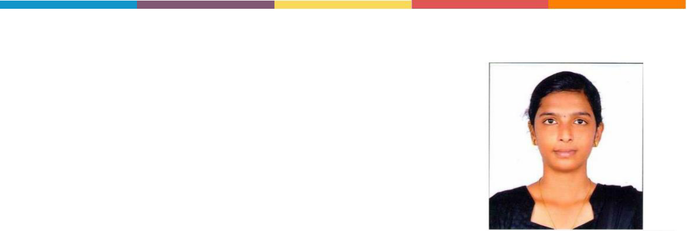
Kiruba Thangarasu

kirubakiruba9185@gmail.com

+91 9384515849

1/55 Trichy Main road,
Pagalavadi, Thuraiyur (tk),
Trichy-621014

https://www.linkedin.com/in/kirubathangarasu https://github.com/kirubatom

CAREER OBJECTIVE:

To have a growth oriented and challenging career, where I can contribute my knowledge and skills to the organization and enhance my experience through continuous learning and teamwork.

ACADEMIC QUALIFICATION:

Qualification | University/Board | Institute | Year of Passing | Percentage/CGPA
B.E- Computer |  | K Ramakrishnan
science & | Anna University | college of | 2023 | 8.3(CGPA)
Engineering |  | engineering
 |  | Vimala Matriculation
HSC | State Board | Higher Secondary | 2017 | 91.5%
 |  | School
 |  | Sowdambikaa
SSLC | State Board | Matriculation Higher | 2015 | 96.2%
 |  | Secondary School

TECHNICAL SKILLS:

Languages: Python, Java

OS/ Platform: Linux-Ubuntu, Windows 7 to 10

Good working skills in Pandas and data visualization

PROJECTS:

Video games sales predication using machine learning algorithm like Linear regression, Random forest and Decision tree.

Mobile price predication using Naive Bayes machine learning algorithm.

WORKSHOP & CERTIFICATIONS:

- Got certified on quiz and webinars.

- Intermediate level completion in “JAVA programming” at Hackerank Platform. w
- Participated in Workshop on “Web Development” of Prayatna’20 conducted at Madras Institute of Technology.

- Participated in webinar entitled “Product development”at K.ramakrishnan college of engineering

- Presented a paper entitled “Laser Application” organised by Craters Club.

- Completed “Fundamentals of Digital Marketing” organised by Google.
- Completed Japanese language (N5 level)

PERSONAL TRAITS:

Good interactive skills Time management

Trilingual

Have the capability to lead a team

Have the Ability to co-ordinate and work Adjust according to situation and work

INTERESTS:
 | Data Analytics
 | Buildings best models
 | Accuracy predication
PERSONAL PROFILE:
 | Name |  |  | :T. Kiruba
 | Age |  |  | :22
 | Sex |  |  | :Female
 | Marital status |  |  | :Single
 | Father’s Name |  |  | :Mr. M. Thangarasu
 | Mother’s Name |  |  | :Mrs. R. Jeyalakshmi
 | Nationality |  |  | :Indian
 | Medium of Education |  |  | :English
Proficiency in Language :English, Tamil & Japanese

DECLARATION:

I here by declare that the above given facts are true to the best of my knowledge and assure that I will perform my duties dedication and to the satisfaction of my superiors.

